Lab 5 manual: Resistivity and Linearity of Ohm’s Law
Dr. D. Beznosko
7/11/2026
For PHYS 1112L only.
(Lab outcomes: Instrumental error; linear mapping measurement, deviation from linearity)

Abstract
This document describes the measurement of material resistivity using a linear mapping measurement process on a long thin wire. The use of both x- and y-error bars for the model testing is introduced. Deviation from linearity for Ohm’s law is measured.

Introduction
Resistance to the electric current is the property of the actual circuit element in its shape and form and it includes not only the property of the material it’s made of, but the geometric factor as well. The property of bulk material is called resistivity $ρ$ – do not confuse with density! Anything about Ohm’s law and its usage? Why do we think that it is linear?

Experimental Setup
The experimental setup is shown in Figure 1 and contains the Wheatstone bridge apparatus and an ohmmeter (or a multimeter). PASCO [1] setup is used to measure voltage and current in the apparatus.
Figure 1: The experimental setup consists of Wheatstone bridge apparatus and multimeter. PASCO setup is not shown here.
Multimeter
Wheatstone bridge apparatus

Procedure
Connect the Wheatstone bridge to the power output of the PASCO computer interface. In the Capstone software, configure the readout of the signal generator power output voltmeter and ammeter. Ensure that the voltage limit is at 5V as higher voltage can cause damage to the equipment and you as well! Set control to Auto. The up and down buttons should adjust by 100mV and not 1V (red arrows).
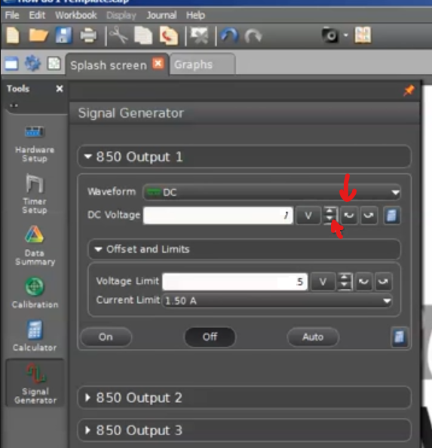
After settings are verified, start recording data and make two plots: of V vs. time and I vs. time. You can do this as a single run without pressing the stop button. Start the run, adjust the voltage to 0.5V and wait about 20-30 seconds. In steps of 0.5 V go all the way to 5V. After completion of the run, reduce the voltage back to 0V (can be done quickly) and then stop the run.
Use the selection tool and measure the average and standard deviation of V and I for each step. Try to choose the 20-30 rightmost points on each plateau. The displayed standard deviation by the program is the statistical error. Move the selection box around, try resizing it, do this 5 times and record the means – the stdev of these means is your systematic error. Combine both errors in quadrature as usual to be used as error bars in the plot. Keep data ordered as we want the voltage and the current that correspond to each other. Time information is not needed.

Experimental Data
The results of the measurements should be organized similarly to Table 1. Also, for the voltage and current. Think about how to organize the tables. The error can be listed in a different column or as value ± error unit. Use SI units! May be this should be in appendix?
Table 1: Experimental data. As you have few data points, show all of them here.
V, V | I, $A$
 | ERRORS!!!

Provide description about each entry as needed, don’t just leave the table without text in this section. Organize well so that data takes up less space, but everything needed is included.

Theory
Consider equation 1 that shows the Ohm’s law:
$$V=IR\left(1\right)$$
with $R$ being the resistance of the wire segment, and $I$ – electric current in the wire. Always use equation editor and number the equations so that they later can be referenced as eq. 1 or equation 1. Other equations may need to be used for this lab.

Analysis
We want the slope to be resistance – what should be the plotted on the axes? Figure out the total errors for the error bars. Do the plot. If errors bars are not visible, mention this in the text.
Do the linear fit (pol1 using https://sos.clayton.edu/physics/chi2/).
Look at the ${χ^{2}}/{ndf}$ value. The error bars are small as your measurement was very accurate and precise – is your fit quality looking good? Use the chi square to p-value calculator (such as [2] or similar) to convert your $χ^{2}$ and ndf to probability. Is that a good fit? If Ohm’s law is linear, does that fit your result? What if it’s not? What could be the reason?
Do a plot of residuals. Residuals are the difference between the ‘theoretical’ value given by the fit line equation $f\left(I_{i}\right)$ and the actual data point value $V_{i}$ (similar to $χ^{2}$ calculation when its done in Excel, just not squared!). Does this plot look random or of any other recognizable shape that indicates correlations in the residuals? Speculate about the reason this may be so.
Do the linear fit for the residuals using pol1 function, find the resistivity with error. Is the slope error larger than the slope? Try using pol0 function – what do you think about the result?

Conclusion
Remember to include references and appendices as needed. Comment on your result. What did you learn in performing this measurement? Where else can it be used? Can it be improved?

Bibliography

[1] | PASCO Scientific, 10101 Foothills Boulevard, Roseville, California 95747 USA.
[2] | "Chi^2 to P calculator," [Online]. Available: http://courses.atlas.illinois.edu/spring2016/STAT/STAT200/pchisq.html.

